AI Assisted Coding (III Year) Assignment
Name: U. Rohith
HT NO: 2303A52198
Batch: 35

Lab 7: Error Debugging with AI – Systematic Approaches to Finding and Fixing Bugs
Week 4 – Monday
Lab Objectives
- To identify and correct syntax, logic, and runtime errors in Python programs using AI tools.
- To understand common programming bugs and AI-assisted debugging suggestions.
- To evaluate how AI explains, detects, and fixes different types of coding errors.
- To build confidence in using AI to perform structured debugging practices.

Task 1: Syntax Error – Missing Parentheses in Print Statement
Buggy Code
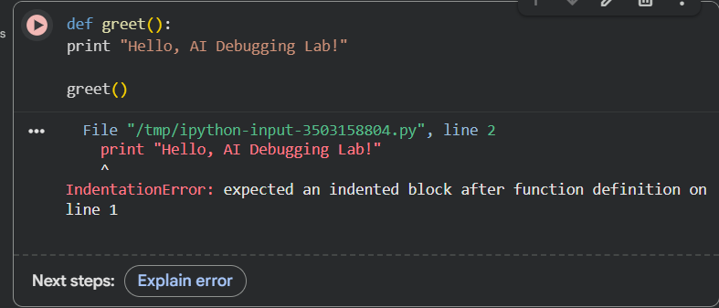
Observed Error
- SyntaxError occurs because Python 3 requires parentheses in print().
AI Fix (Corrected Code):
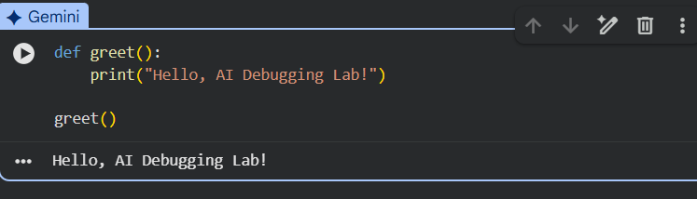
Explanation
- In Python 3, print is a function, so parentheses are mandatory.
- Indentation was also corrected.

Task 2: Logic Error – Incorrect Condition in If Statement
Buggy Code
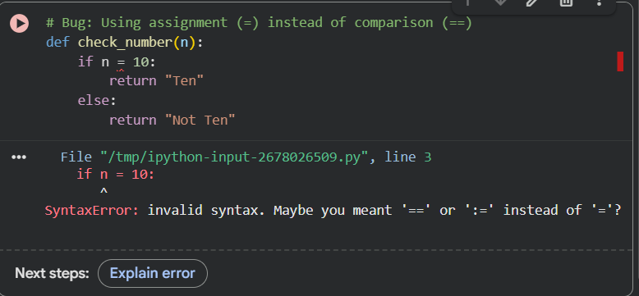
Why This Causes a Bug
- = is used for assignment, not comparison.
- Conditions require ==.
AI Fix (Corrected Code) :
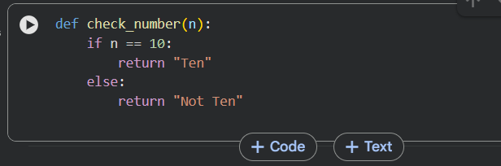

Task 3: Runtime Error – File Not Found
Buggy Code
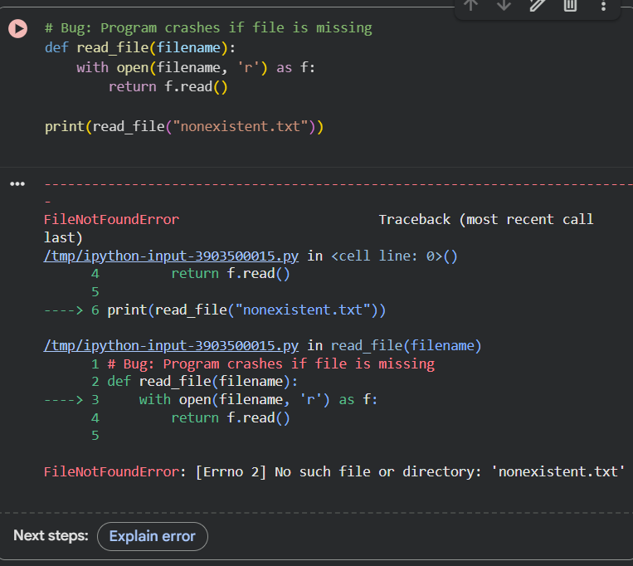
Observed Error
- FileNotFoundError occurs when file does not exist.
AI Fix (Safe Code with Try-Except):
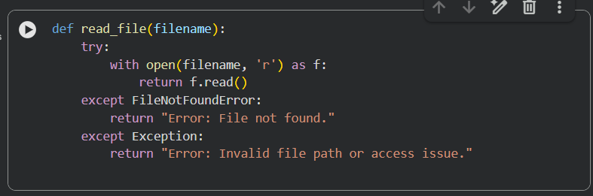

Task 4: Calling a Non-Existent Method
Buggy Code:
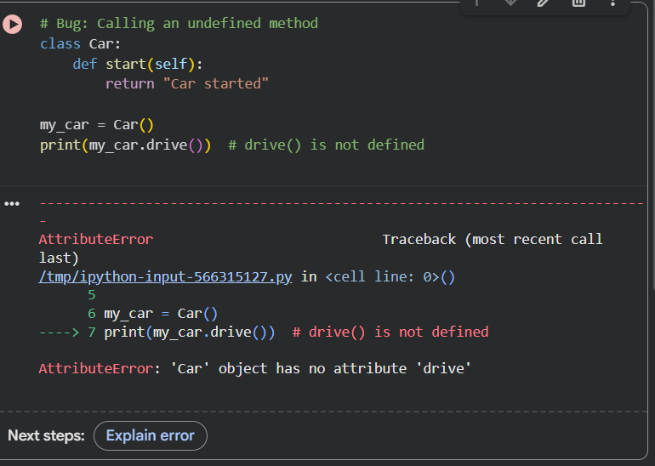
Problem
- drive() method does not exist, so AttributeError occurs.

AI Fix: Correct the Method Call:
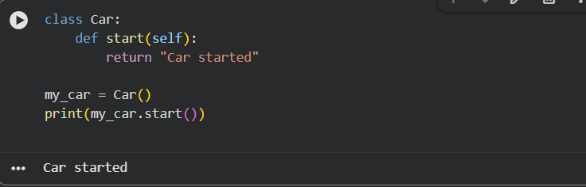

Task 5: TypeError – Mixing Strings and Integers in Addition
Buggy Code:
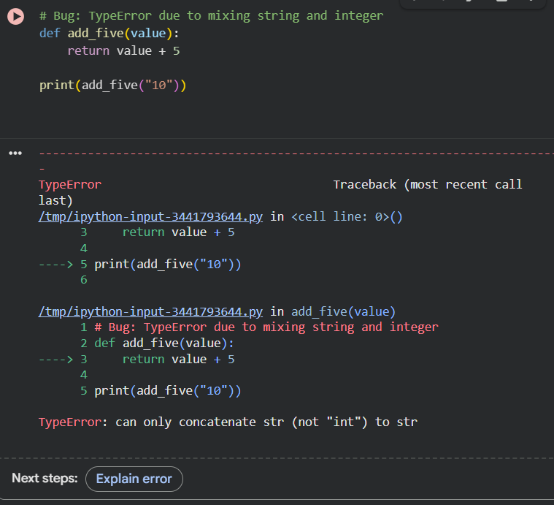
Observed Error
- TypeError occurs because "10" is a string and cannot be added to integer 5.

AI Correction: String Concatenation:
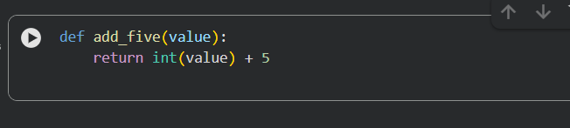
Final Conclusion
This lab demonstrated how AI tools help in debugging different types of errors:
- Syntax Errors (missing parentheses, indentation)
- Logic Errors (wrong operators in conditions)
- Runtime Errors (missing files, invalid paths)
- Attribute Errors (undefined method calls)
- Type Errors (mixing incompatible data types)
AI-assisted debugging improves productivity, but human understanding is necessary to validate fixes and write reliable code.

